

**SCHOOL OF COMPUTER SCIENCE ENGINEERING**

**AND INFORMATION SYSTEMS**

**WINTER SEMESTER 2024-2025**

**PMCA601P – FULL STACK WEB DEVELOPMENT LAB**

**AJAX - EXERCISE**

**SUBMITTED ON: 10 – FEB - 2025**

**SUBMITTED BY-**

**AKASH KUMAR BANIK**

**PROGRAM: MCA**

**REGISTER No.: 24MCA0242**

**Q1.**

**i) Design a table in the format given below using HTML and JQuery selectors.**

**ii) Apply different background for odd and even rows of the table.**

**iii) Apply different CSS for table header using JQuery selectors.**

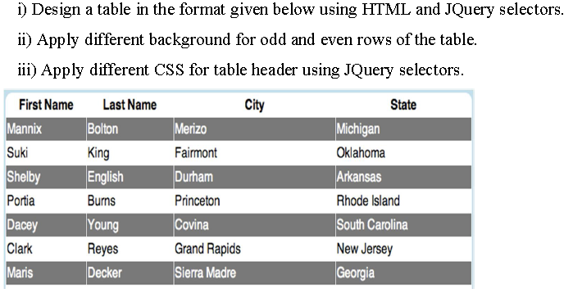

**CODE:**

<!DOCTYPE html>

<html lang="en">

<head>

<meta charset="UTF-8">

<meta name="viewport" content="width=device-width, initial-scale=1.0">

<title>Document</title>

<script src="jquery-3.7.1.min.js"></script>

<style>

table{

width: 80%;

margin-left: 60px;

}

table,tr,th,td{

padding: 8px;

border: 1px white solid;

border-collapse: collapse;

}

table tbody{

text-align: left;

}

</style>

</head>

<body>

<center><h1>AKB jQUERY</h1></center>

<table>

<thead>

<tr>

<th>First Name</th>

<td>Last Name</td>

<th>City</th>

<th>State</th>

</tr>

</thead>

<tbody>

<tr>

<td>Mannix</td>

<td>Bolton</td>

<td>Merizo</td>

<td>Michigan</td>

</tr>

<tr>

<td>Suki</td>

<td>King</td>

<td>Fairmont</td>

<td>Oklahoma</td>

</tr>

<tr>

<td>Shelby</td>

<td>English</td>

<td>Durham</td>

<td>Arkansaa</td>

</tr>

<tr>

<td>Portia</td>

<td>Burns</td>

<td>Princeton</td>

<td>Rhode Island</td>

</tr>

<tr>

<td>Dacey</td>

<td>Younf</td>

<td>Covina</td>

<td>South Carolina</td>

</tr>

<tr>

<td>Clark</td>

<td>Reyes</td>

<td>Grand Rapids</td>

<td>New Jersey</td>

</tr>

<tr>

<td>Maris</td>

<td>Decker</td>

<td>Sierra Madre</td>

<td>Georgia</td>

</tr>

</tbody>

</table>

<script>

$(document).ready(function(){

$("tr:odd").css("background-color","red").css("color","White");

$("tr:even").css("background-color","lightgreen").css("color","black");

$("thead").css("font-weight","900").css("text-align","center");

$("table").css("border","3px red dashed");

});

</script>

</body>

</html>

**OUTPUT:**

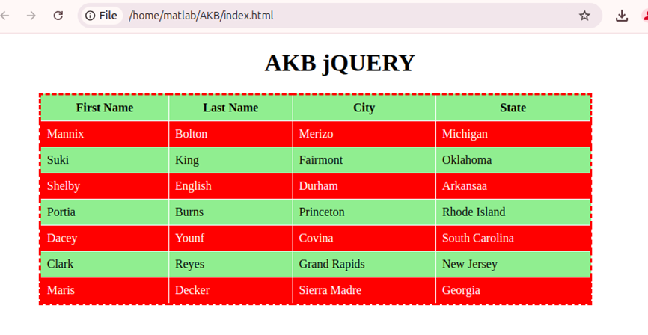

**Q2. Assume that the external site named "http://date.jsontest.com/" contains the following JSON data: {"date": "10-03-2024", milliseconds_since_epoch": 1727931665031, "time": "05:03:40 AM"}**

**Implement appropriate AJAX script to access the above site and display the data as per the format given below:**

**Date:10-10-2024 Time:05:03:40 AM**

**CODE:**

<!DOCTYPE html>

<html lang="en">

<head>

<meta charset="UTF-8">

<meta name="viewport" content="width=device-width, initial-scale=1.0">

<title>Fetch Date and Time</title>

</head>

<body>

<h2>Current Date & Time</h2>

<button onclick="fetchDateTime()">Get Date & Time</button>

<p id="output"></p>

<script>

function fetchDateTime() {

let xhttp = new XMLHttpRequest();

xhttp.open("GET", "jsontest.json", true);

xhttp.onreadystatechange = function () {

if (xhttp.readyState === 4 && xhttp.status === 200) {

let response = JSON.parse(xhttp.responseText);

let formattedOutput = `Date: ${response.date} Time: ${response.time}`;

document.getElementById("output").innerHTML = formattedOutput;

}

};

xhttp.onerror = function () {

document.getElementById("output").innerHTML = "Error fetching data.";

};

xhttp.send();

}

</script>

</body>

</html>

**OUTPUT:**

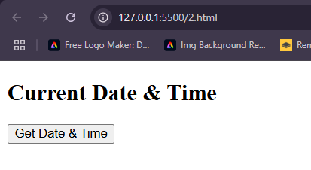

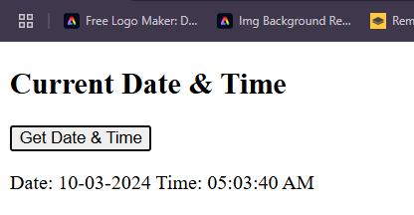

**Q3. Building a web application that fetches and displays user profiles from a remote server using the AJAX concept. The server provides aJSON response containing user details like name, age, and email. Create an interface where users can search for aprofile by entering ausername, and the application will display the corresponding user details.**

**CODE:**

<!DOCTYPE html>

<html lang="en">

<head>

<meta charset="UTF-8">

<meta name="viewport" content="width=device-width, initial-scale=1.0">

<title>Document</title>

<script src="jquery-3.7.1.min.js"></script>

</head>

<body>

<center><h1>AJAX-JSON</h1></center>

<h3>Enter UserName to look for:</h3>

<input type="text" name="username" id="username">

<button type="submit" onclick="searchDetails()">Search</button>

<div id="output"></div>

<script>

function searchDetails(){

var username=document.getElementById("username").value.trim();

if(username===""){

alert("Please enter a username")

return;

}

const xhttp=new XMLHttpRequest();

xhttp.open("GET","employee.json",true);

xhttp.onreadystatechange= function(){

if(xhttp.readyState===4 && xhttp.status===200){

let emp_data = JSON.parse(xhttp.responseText);

let user = emp_data.employees.find(user => user.username === username);

let output_div = document.getElementById("output");

if(user){

output_div.innerHTML=`

<h3>User Details</h3>

<p><b>Name:</b>${user.name}</p>

<p><b>Age:</b>${user.age}</p>

<p><b>Email:</b>${user.email}</p>

`;

} else {

output_div.innerHTML=`<h3>User not found</h3>`;

}

}

};

xhttp.send();

}

</script>

</body>

</html>

**OUTPUT:**

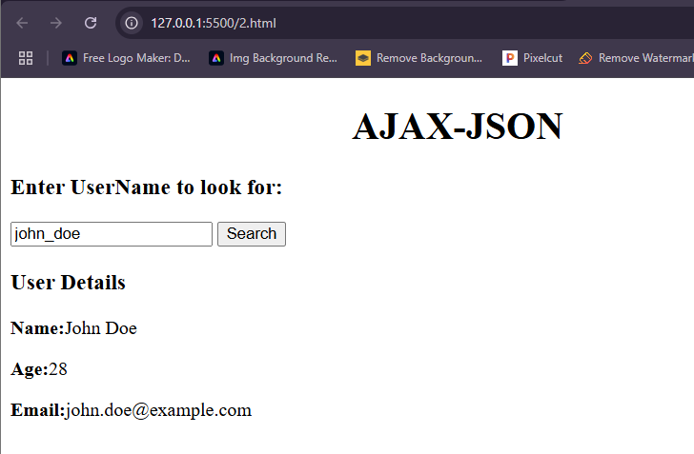

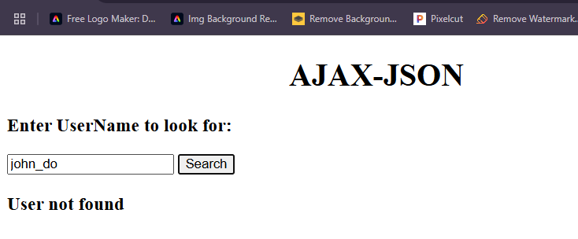

**Q4. Write the JQuery code to add behavior to the following page for keeping track of a to-do-list.**

**a) Ihe page UI allows the user to type an item into a text box. The user can click the "add" button to add the item to the bottom of the list. Each word in the phrase should be inserted as a li, inside an ul with the id of list.**

**b) If the user wishes to remove an item he or she can type the text of the item he or she wishes to remove in the text box and click the "remove" button. This should be case insensitive. For example, if the list only contains "foo" and the user tries to remove "FoO", it should be removed. If the user tries to remove an item that is in the list miltiple times, only the first occurrence should be removed.**

**c) The items should have background colors that alternate between white and yellow (first white, then yellow, then white, yellow, etc.). should still be the ease no matter how many items are removed or added and no matter what order these operations are done in.**

**d) The code should work for multiple clicks of the buttons. On each click it should clear any previous information you typed in the input boxes.**

**These screenshots show the state after items have been added and the state after items have been removed.**

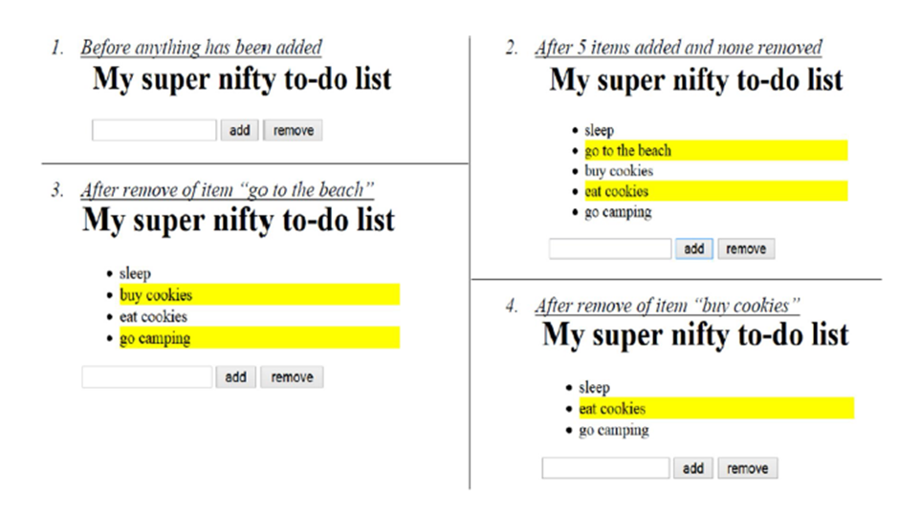

**CODE:**

<!DOCTYPE html>

<html lang="en">

<head>

<meta charset="UTF-8">

<meta name="viewport" content="width=device-width, initial-scale=1.0">

<title>To-Do List</title>

<script src="https://code.jquery.com/jquery-3.6.0.min.js"></script>

<style>

ul { list-style-type: none; padding: 0; }

li { padding: 5px; }

.white { background-color: white; }

.yellow { background-color: yellow; }

</style>

</head>

<body>

<h2>To-Do List</h2>

<input type="text" id="todoInput" placeholder="Enter task">

<button id="addButton">Add</button>

<button id="removeButton">Remove</button>

<ul id="list"></ul>

<script>

$(document).ready(function() {

$('#addButton').click(function() {

var todoText = $('#todoInput').val().trim();

if (todoText !== '') {

var listItem = $('<li>').text(todoText);

$('#list').append(listItem);

$('#list li').each(function(index) {

$(this).removeClass('white yellow');

if (index % 2 === 0) {

$(this).addClass('white');

} else {

$(this).addClass('yellow');

}

});

$('#todoInput').val('');

}

});

$('#removeButton').click(function() {

var todoText = $('#todoInput').val().trim().toLowerCase();

if (todoText !== '') {

$('#list li').each(function() {

if ($(this).text().toLowerCase() === todoText) {

$(this).remove();

return false; // Stop after the first match

}

});

$('#list li').each(function(index) {

$(this).removeClass('white yellow');

if (index % 2 === 0) {

$(this).addClass('white');

} else {

$(this).addClass('yellow');

}

});

$('#todoInput').val('');

}

});

});

</script>

</body>

</html>

**OUTPUT:**

